24.30: a) If the separation distance is halved while the charge is kept fixed, then the capacitance increases and the stored energy, which was 8.38 J, decreases since 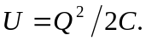 Therefore the new energy is 4.19 J.
b) If the voltage is kept fixed while the separation is decreased by one half, then the doubling of the capacitance leads to a doubling of the stored energy to 16.76 J, using 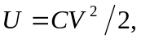 when V is held constant throughout.

